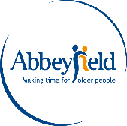

Dear

Thank you for your recent enquiry for more information on Abbeyfield Brecon House.

We are a member of The Abbeyfield Society. The support and welfare of all who choose to live with us is at the heart of everything we do at Abbeyfield, and this remains our top priority during the current pandemic situation.

Our staff are provided with regularly updated guidance about COVID-19 which follows Government and Public Health advice, and we are taking every precaution to ensure the safety of both our residents and staff.

I am pleased to send you the Prospective Resident Application Form, a brochure of our house/home, a sample menu and an information sheet which provides some more details around the process for moving in and our safety measures.

I would be delighted to arrange a live video tour of the house so you get a feel for the house and the opportunity to ask any questions you may have.

In the meantime, do feel free to contact me if you have any further questions by replying to this email or by phoning 01874 611533

Thank you for your interest and I look forward to hearing from you soon.

Kind regards,

Emma Debenham

House Manager

